Atretefact For Release Two, Sprint Three & Four Burndown Charts

Release Two Burdown Chart

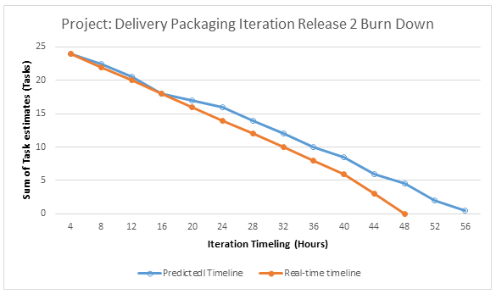

Sprint Three

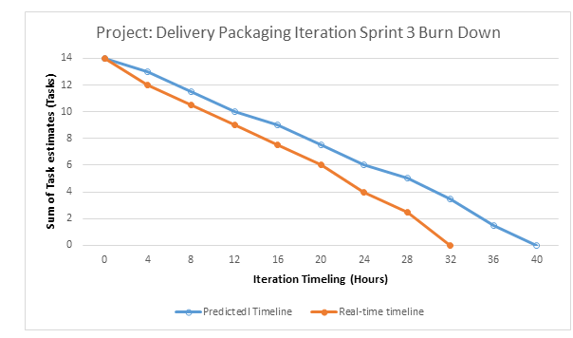

Sprint Four

